July 26, 2023

Dear Parent/Guardian:

New York State has passed a law requiring schools to request Dental Certificates for the following grades: Kindergarten, 2nd, 4th, 7th & 10th, as well as new students entering into a district. Please have your child’s dentist complete the bottom of this letter and return it to the Health Office as soon as possible.

Should you have any questions, do not hesitate to call the Health Office at 631-737-1492.
Please return this certificate back to Cleary School for the Deaf, attention to Madeline Michel via fax at 1-737-210-4796 or email mmichel@clearyschool.org

Thank you.

Kathleen Kerzner,
Principal

xxxxxxxxxxxxxxxxxxxxxxxxxxxxxxxxxxxxxxxxxxxxxxxxxxxxxxxxxxxxxxxxxxxxxxxxxxxxxxxxxxxxxx
PLEASE RETURN TO THE HEALTH OFFICE

Student: _________________________________ DOB: _______________________

Complete dental examination on: ______/______/_______. Treatment needed ____yes _____no

Recommendations/Remarks: ____________________________________________________________

Examiner’s Signature: ______________________________________________
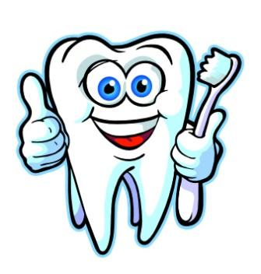
Office Stamp:

