Cleary School for the Deaf – 301 Smithtown Blvd, Nesconset, NY 11767 631-588-0530

STUDENT SICK POLICY
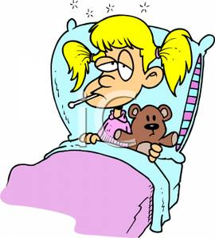

Although some illnesses do not require exclusion, some illnesses require a child to be excluded from school to prevent the spread of infection. Although it is important that your child be in school, there are some situations when it is best to keep your child home for a day to rest or arrange for an appointment with your health care provider.

Please keep in mind that we have immuno-compromised students who attend our school and they can be very susceptible to infectious illness. Abiding by the guidelines below will help us promote a healthy environment for all of our children.

Please keep your child at home if he/she has one or more of the following signs/symptoms:

● Persistent fever greater than 100.0°, YOUR CHILD MUST BE FEVER FREE (LESS THAN 100º) FOR MORE THAN 24 HOURS WITHOUT THE ADMINISTRATION OF TYLENOL OR IBUPROFEN BEFORE RETURNING TO SCHOOL.

● Vomiting and/or Diarrhea within the past 24 hours. Your child may be too sleepy or weak from an illness, like vomiting and/or diarrhea, to profit from sitting in class all day.

● Significant cough that makes a child feel uncomfortable, especially if it has kept the child awake at night.

● Sore throat that is severe, accompanied by fever and/or feeling ill, that persists longer than 48 hours or after known exposure to a confirmed case of Streptococcal throat infection. Your child must be taking an antibiotic for 24 hours before returning to school.

● Undiagnosed Rash: any child arriving at school with a rash will be sent home if the child does not have a note from their doctor stating that the rash is not contagious.

● Red, runny eyes, especially with any crust or discharge that may be indicative of conjunctivitis (pink-eye).

● Nasal discharge that is thick and not clear in color, especially if accompanied by facial pain or headache.

Students returning to school after a surgical procedure, stitches, fracture, highly contagious or extended illness must provide a doctor’s note authorizing their return to school. Any physical restrictions recommended by your physician should be included in this note.

Remember, whenever you keep your child home from school, whether it is from illness, or for a scheduled doctor’s appointment, please call the front desk at 631-588-0530 or the school nurse at 631-737-1492. An absent note should also be sent in with your child upon their return to school. Please indicate if your child is on any medication to treat illness as some medication can affect a child’s behavior and/or their stomach.

Thank you for your cooperation.

Revised 07/22/16

